**Project Design Phase-II**

**Data Flow Diagram And User Stories**

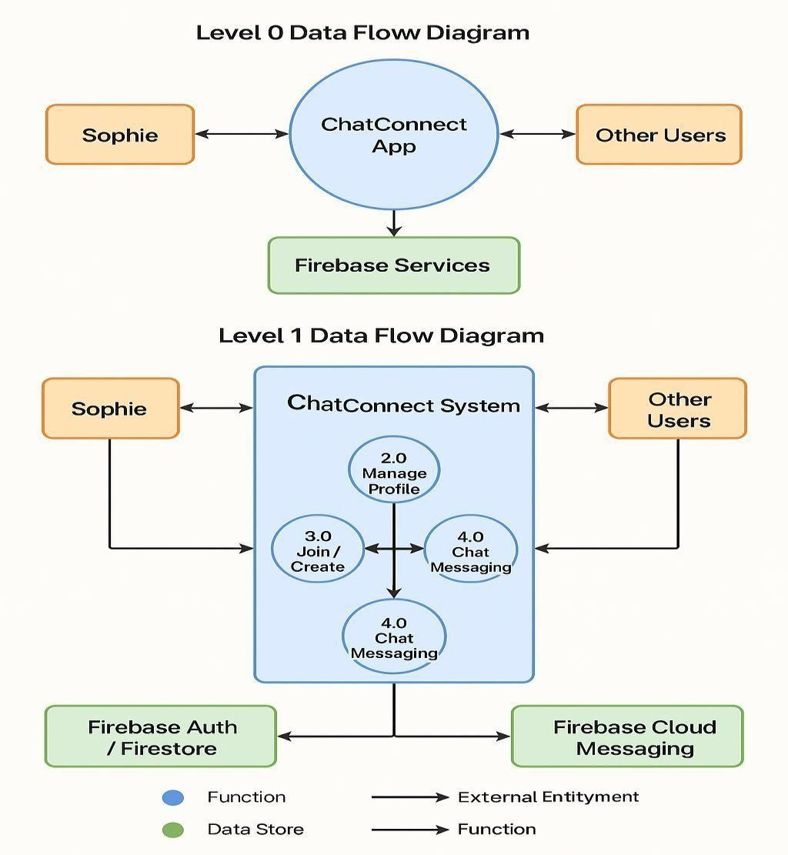**Data Flow Diagram:**

**User Stories:**

|  |  |  |  |  |  |  |
| --- | --- | --- | --- | --- | --- | --- |
| **User Type** | **Functional**  **Requirement**  **(Epic)** | **DFD Process Number** | **User Process / Task** | **Data Flow / Storage** | **Priority** | **Release** |
| **Sophie (End User)** | **Manage Profile** | **2.0** | Manage profile details (name, email, picture, etc.) | Firebase Auth / Firestore | High | Sprint1 |
| **Sophie (End User)** | **Join or Create Chat**  **Rooms** | **3.0** | Browse, join, or create new chat rooms. | Firebase Auth / Firestore. | High | Sprint2 |
| **Sophie (End User)** | **Real-Time Chat**  **Messaging** | **4.0** | Send/receive messages, multimedia, emojis | Firebase Cloud Messaging, Firestore. | High | Sprint3 |
| **Other Users** | **Messaging &**  **Collaboration** | **4.0** | Participate in real-time conversations. | Firebase Cloud Messaging,  Firestore. | High | Sprint4 |
| **Firebase Services** | **Authentication &**  **Data Storage** | **-** | Store and sync messages, handle auth & notifications. | Firebase Auth / Firestore , Firebase Cloud Messaging | Core  Service | Sprint5 |